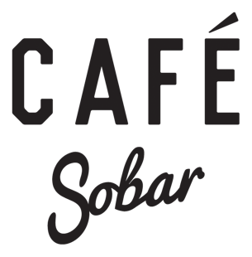
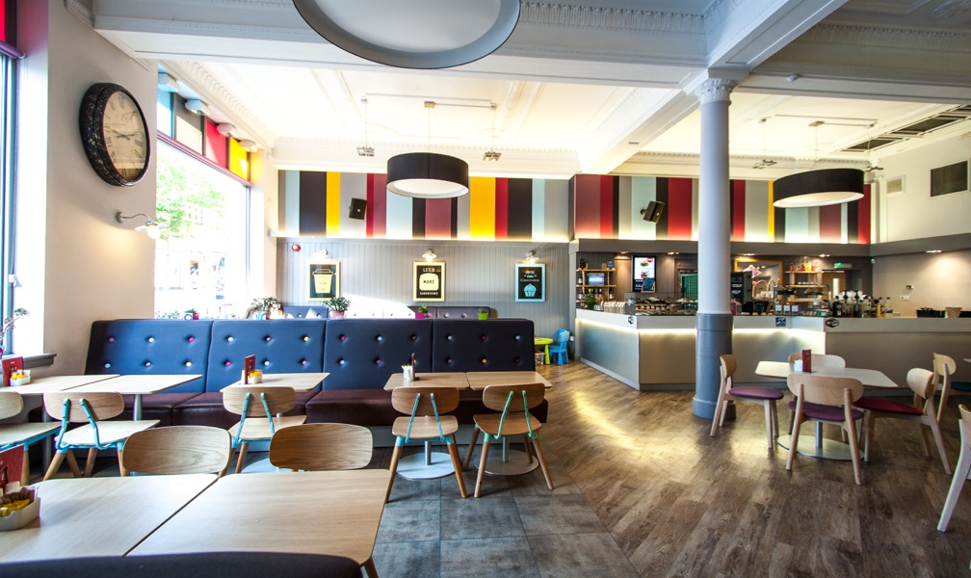
Access Statement

August 2015
This access statement does not contain personal opinions as to our suitability for those with access needs, but aims to accurately describe the facilities and services that we offer all our guests/visitors.

Contents

3 ………………… Welcome

4 …..................... Getting Here

5 ………………... Parking

6 ………………... On Arrival

7 - 9 …………….. Our Venue

10 ……………….. Additional information

11 ……………...... Contact information

Welcome
Situated in the city centre of Nottingham, Café Sobar offers a perfect dining experience and modern English cuisine in a laid back relaxed environment. Our profits go towards the Double Impact charity which helps people in recovery get back on their feet and back into work.
Located in the heart of the city centre the train station, bus access, shops and tram are within 10-minute walking distance. The Café is situated on a slight hill with a 1:29 gradient.
We offer:
- Easy wheel-chair access to our Cafe with a portable ramp leading into the Café which a member will staff will put out when the doorbell outside of the door is rang.
- An accessible toilet.
- A warm welcome to people with assistance dogs.
- Fresh, locally sourced products and we do our best to cater for all dietary requirements. Please contact us in advance with any specific requests and dietary needs.
- Hearing loop which is located at the bar.

We look forward to welcoming you. If you have any queries or require any assistance please phone 0115 824 0364 or email Enquiries@Sobar-nottingham.co.uk.

Getting here
For full details and maps of how to reach us please see our address on our ‘visit us’ page on our website www.sobar-nottingham.co.uk/visit-us/. You can also plan your journey by car or public transport using a journey planning website such as www.travelineeastmidlands.co.uk. Simply enter your postcode and ours, which is NG1 6DQ to get directions.
Train
- The nearest train station is the Nottingham Railway Station, which is just 0.5 miles away (a 10-15 minute walk).
- Information about the accessibility of the station can be found at: www.nationalrail.co.uk/stations/sjp/NOT/stationOverview.xhtml
- Taxis are available at the station.
Taxi
If you require an accessible taxi this can be booked in advance with: DG Cars Address: 22A Lower Parliament Street, City Centre, NG1 3DA Website: http://www.dgcars.co.uk/ Phone: 0115 9 500 500.
Bus
- The nearest bus stop is 10m/10yds from the restaurant - ask the driver for the stop on Friar Lane.
- All buses can accommodate a wheel chair. More information about the accessibility of buses can be found at www.nctx.co.uk/customer-services/information-centre-category/accessibility.
- The No 5,6,7,8,9 and 10 runs to the railway station every 5 minutes.
- There is a shelter with seating.

Drop off point

- There is an area where people can be dropped off which has a dropped kerb for easy access. This is located directly across the road from the café outside of The Walkabout and is 10m away from our front door.
Car
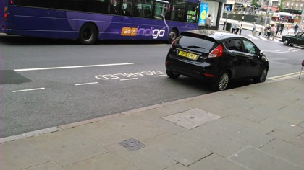
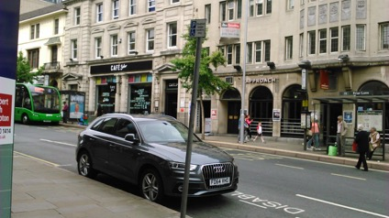
- There is accessible parking across the road outside of Costa Coffee. It is 15m away from our front door. The road is very busy as it is main drop off point for buses just outside of our café. However, there is a zebra crossing 5m away from the disabled parking spaces. There is room for 4 cars to fit into the disabled parking spaces and they are clearly marked with the Blue Badge and road markings.

- Parking is free of charge.
- The surface from the car parking to the front door of the cafe is paved.
- Alternative parking is available at the Victoria Centre and Broadmarsh Centre. There is a charge, prices vary by the hour, you can check these at:
http://intu.co.uk/victoriacentre/centre-information/parking
www.nottinghamcity.gov.uk/article/23462/Broadmarsh-Car-Park

Arrival and Entrance
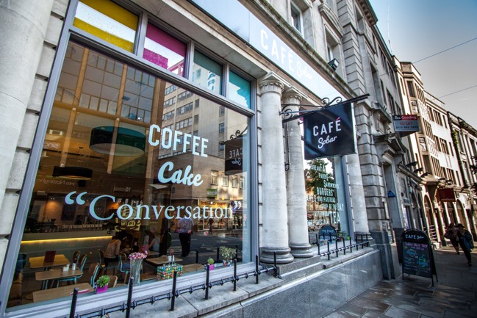
- The pavement outside the Café is on a low gradient of 1:29.

- There is one step in front of the door which is 1 x100mm/3.9ins high.
- There is a portable ramp available which a member of staff will put out for anyone who requires it. There is a bell outside of the door on the wall which when pressed a member of staff will come to the door to help.
- If visitors require any assistance opening the door a member of staff will also be happy to help and you can get their attention by pressing the bell outside.
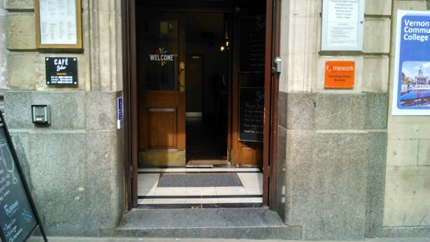
- The width of the door 1.2m/47ins wide.

Café & Bar Area
- The Café and bar area are located on the ground floor and is on level / step free throughout.
- There is a choice of seating between our table and chairs or our sofa-like seating.
- The seating area has upright chairs without arms and there is leather sofa-like seating.
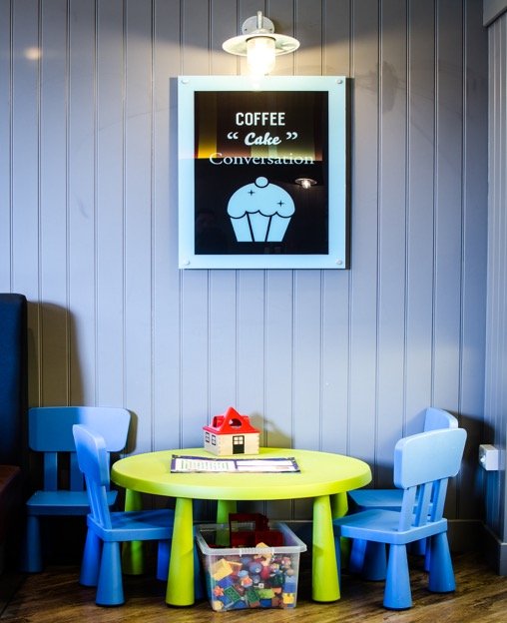
- There is a children's play area with soft chairs and a small table.

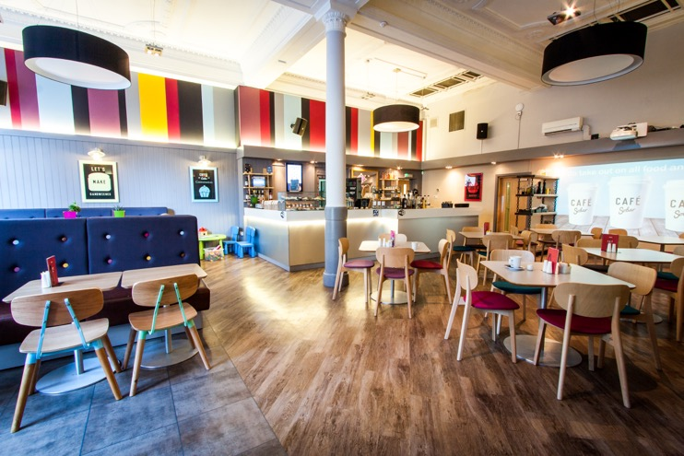
- The tables and chairs are well spaced apart.
- The space under between the table top and floor is 700mm/27.5ins for easy access.
- The seating can be rearranged.
- The lighting throughout the café is natural daylight. Fluorescent overhead and wall lighting is used.
- The flooring is a mixture of wood and tile. The distance to the nearest WC is 10m.
- There is a hearing loop at the till with clear signage on display.
- We cater for all dietary needs. You can view our menu on our website www.sobar-nottingham.co.uk/menu/. If you require any more information about our menu please contact us beforehand.
- We offer table service and self-service.
- There is a TV which has subtitles switched on.
- If there is anything else you require please just ask and a member of staff will be more than happy to help.
- Our menu has large print. However, a member of staff will be happy to assist you if required.

Customer Toilets
- Customer toilets, including a unisex accessible toilet, can be found at the end of the bar area.
- The door opens outwards and has a clear opening width of 838mm/33ins. There is a horizontal rail situated on the rear of the door to enable the doors closure from the hinge side.
- The lock on the door can be opened from the outside in the case of an emergency.
- The transfer space beside the toilet in on the right and has a clear space of 1m/43ins.
- Horizontal rails are fitted either side of the WC. A vertical rail is fitted beside the WC and is held up by a bracket on the wall. Vertical grab rails are fitted on either side of the basin.
- The basin is low to floor 508mm/20ins off the ground. There are level taps.
- The toilet is 304mm/12 inches in height.
- The toilet is well lit with fluorescent lighting.
- Non-slip laminate flooring.
- There is a clear colour contrast between surfaces.
- There is an emergency pull cord situated next to the toilet.
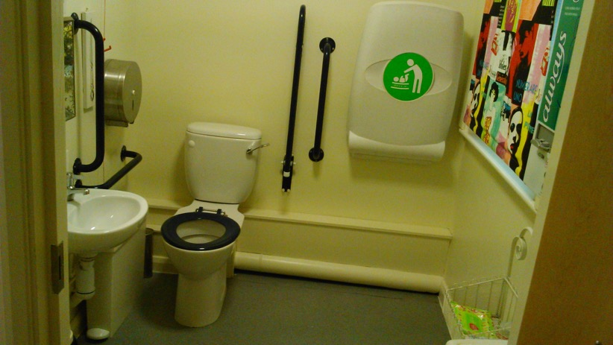
- There is a baby changing station in the accessible toilet.
Additional Information
- As part of our pledge to help and support our customers’ needs our staff undertake disability awareness training.
- We have a set of evacuation procedures; accessibility is taken into consideration in our fire assessment. Should you require assistance someone will help you evacuate the building.
- Assistance dogs are welcome.
- Water will be provided for assistance dogs, just ask a member of staff and they will be happy to help.
- Clear and easy to read signs are used in the Café.
- Our access statement is available in large print and can be found on our website www.sobar-nottingham.co.uk/visit-us/
- Free Wi-Fi is available throughout the Café and access can be gained by asking a member of staff for the password. There is information for local taxis on the walls (what about accessible taxis?).
- There is a local service for ShopMobility. It is a 4 minute walk away from the train station. You can find it on google maps by searching 'NG1 3QN'.
Future Plans
- We are always looking to making things easier for our customers and as a part of this we will be looking to get an automatic door sometime in the future.
- New Staff will undertake Disability Awareness training
- We are planning on reviewing the accessibility of our website; your comments are welcome to assist us in any changes that need to be made.

Feedback

We are always looking for ways to improve the service we provide to our visitors. All projects we undertake are accessed for accessibility compliance, so please contact us if you have any comments or suggestions about this access statement or anything else that you think can improve your visit to us:

Contact Information
Address: | Café Sobar, 22 Friar lane, Nottingham, NG1 6DQ
Telephone: | 0115 824 0364
Email: | Enquiries@Sobar-nottingham.co.uk
Website: | www.sobar-nottingham.co.uk/
Hours Of Operation: | Mon - Fri: 08:00 - 18:00, Sat: 09:00 - 18:30, Sun: 10:30 - 16:30
Local Equipment Hire: | ShopMobility Address: Victoria Street, Nottingham, NG1 3QN Website: www.shopmobilityuk.org/ Phone: 0115 915 3888 Email: Info@shopmobilityuk.org
Local Accessible Taxi: | DG Cars Address: 22A Lower Parliament Street, City Centre, NG1 3DA Website: www.dgcars.co.uk/ Phone: 0115 9 500 500
Local Public Transport: | Tram Website: http://www.thetram.net/ Phone: 0115 942 7777 Email: info@thetram.net Train Website: www.nationalrail.co.uk/stations/NOT/details.aspx

